Parkinson Senior Society

Spring 2015

Computer Program Guide

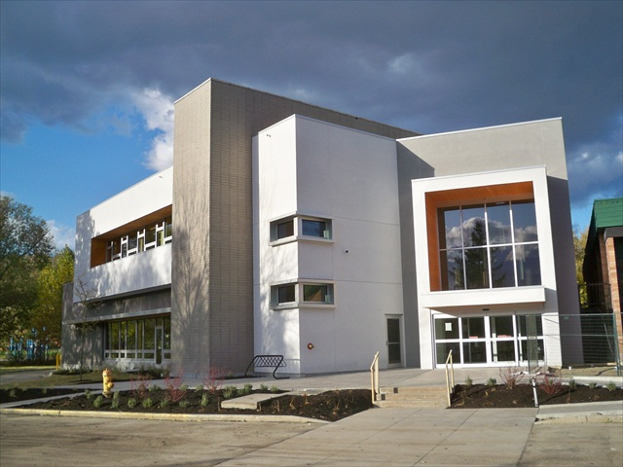

1700 Parkinson Way,
Kelowna, B.C.
762-4108

Web site: www.parkinsonseniors.com
CONTACTS
Parkinson Senior Society  1700 Parkinson Way,  Kelowna, BC V1Y 4P9  E-Mail: parkinsonseniorsociety@shaw.ca | 762-4108  www.parkinsonseniors.com  parkinsonseniorsociety@shaw.ca
Computer Lab Secretary:  Bernie Major | bgmajor@shaw.ca  862-9113

The Parkinson Senior Society Computer Lab has many courses to suit all your interests. Many of our courses have one main instructor and one or two co-instructors, and there are only six students in a class. Detailed Manuals are provided and included in the cost so you can go home and practice your new skills learned in class. In addition, you will find the monthly Computer Help Sessions helpful for your specific questions and concerns.
Information and pre-registration are available by phoning Corrinne at 762-4108. Your placement in the course is assured only once payment has been received two weeks prior to the commencement of the course. Should you be interested in other courses, please let us know.
____________________________________________________________________________
Computer Course Prices
3-hr Courses = $30.00
6-hr Courses = $50.00
9-hr Courses = $65.00
An Annual Membership in Parkinson Senior Society is required at a $15.
Note: If you are taking a computer course it is recommended that you own/have access to a computer. Please be prepared to use a mouse in these classes. If you own a laptop and are not familiar with using the mouse may we suggest a Keyboard and Mouse prior to you taking your chosen class.
Note: All courses are on a first come, first served basis.

Free Technical Support for Seniors
On the last Wednesday of each month
September - November
&
January - May
12.30 – 2:30

Learning the Keyboard & Mouse (3-hours – 1 class - $10.00)

This course will assist those who have never used a computer keyboard or mouse and will prepare you for taking the Computer Basics and other computer courses. You will become familiar with the function of several of the keyboard keys as well as how to properly hold the windows mouse and learn when to right click or left click when using the mouse. Some practice time is included in the three hours.

What Computers Can Do and What to Buy (3-hours – 1 class, $10.00)
Confused as to what to buy? This course provides the student with information to assist with the purchasing of a computer, so you don’t buy something you don’t need or something that will soon be inadequate to do more things that you learn over time.
The course is also designed to inform the students about what they can do with a computer. In addition to playing games, sending and receiving e-mail and surfing the Internet, computers can be very entertaining. Computers can be used to scan and copy documents and photos, listen to music, download photos to make a photo-album and e-mail friends and family, create greeting cards, view slide shows, read newspapers and much, much more.

About Windows 8 (3 hours – 1 class - $30.00)
Microsoft’s Windows 8 is the current Windows Operating System for use on personal computers . Windows 8 introduces significant changes primarily focused towards improving user experience on mobile devices such as “Tablets”.
Learn some of the feature that Windows 8 offers and find out what features are no longer available on Windows 8 that were common in previous versions of Windows Operating Systems.
With the use of PowerPoint presentation and open discussion, this course will provide insight to current users of Windows 8 and those considering purchasing Windows 8 either with a new computer or by upgrading their Windows 7 computer.

Computer Basics Windows 8, 8.1 (9 hours – 3 classes - $65.00)

It is recommended that you are familiar with a keyboard and mouse before taking this class. .
This course is for students new to computers. It covers topics from start-up and shut-down, using the keyboard and mouse, accessing files and folders, using Libraries and finding Help on the computer. The course utilizes hands-on training and each student is provided with a student manual and lots of practice time.

Computer Basics Windows 7 (9 hours – 3 classes - $65.00)

It is recommended that you are familiar with a keyboard and mouse before taking this class. .
This course is for students new to computers. It covers topics from start-up and shut-down, using the keyboard and mouse, accessing files and folders, using Libraries and finding Help on the computer. The course utilizes hands-on training and each student is provided with a student manual and lots of practice time.

Internet (9-hours – 3 classes - $65.00)
It is recommended that you are familiar with a keyboard and mouse before taking this class.
This course focuses on learning how to use Internet Explorer. You will learn how to effectively manage Internet Explorer, locate interesting websites and create/organize Favourites (Bookmarks). You will also learn how to set a homepage of your choice and find out how many places in the world that you can explore using your computer as a library. Downloading files from the Internet will be touched on as well.

E-mail (6 hours – 2 classes - $50.00)
Learn the features of the most widely used E-mail program including: composing messages, formatting text, sending/receiving, replying/forwarding and working with the Contact list. This course also instructs for proper E-mail etiquette. It offers many hands-on exercises including sending and opening attachments, working with E-mail folders and stopping junk mail.

Safe Downloading & Installing Programs: (3-hours – 1 class - $30.00)
Downloading files or programs to your computer and to a “flash drive” can be stressful and could potentially harm your computer. This course explains how downloads work, what to be watchful to prevent unwanted downloads and what programs require updates to be downloaded on a regular basis. Students will have hands on practice downloading, installing and uninstalling programs.

Internet/E-mail Review (3-hours – 1 class - $30.00)
Review some common but seemingly complicated computer skills that will enhance your current computer skills. Re-learn some of the basics of Internet and E-mail such as dragging and dropping, downloading programs from the Internet, setting a home page, deleting temporary files, proper e-mail etiquette, creating favourites, cutting and pasting and more. Time will be set aside for students to ask questions of their choice.
Pre-requisite: Students should have basic computer skills and have experience using Internet and E-Mail.

Cameras and Computers (3-hours –1 class - $30.00)
You took 500 photos last year and you want to show off that picture of you, Terry and that amazing catch. How do you find it? This problem and many more can be solved using Windows Live Photo Gallery (a free program from Microsoft). Learn how to transfer photos from your camera to computer in a more organized fashion. We cover some minor editing, printing, transferring and displaying your photos in a slideshow. The purpose of this three hour course is to help the digital camera users learn how to use their computer along with their digital camera. More specialized topics, such as emailing photos, may be discussed in class as interests and opportunity allow. Please bring your camera, cables and manual to the class.

Computer Photo Editing (6 hours – 2 classes - $50.00)
This is a basic entry level course which offers simple and clear explanations of what you need to know to improve the appearance of your photographs. You will learn how to correct the brightness and color in a photo. Reasons for “Red Eye” are explained, with the method for correction shown. Selecting and cropping to remove unwanted background is demonstrated.

Creating Computer Files and Folders – (3 hours – 1 class - $30.00)
Do you lose things on your computer? Wonder where the letter is that you wrote? Wish your photos were in some sort of order? Then this class is for you. The content of this course will enable the student to properly organize the file systems of their computer. Some topics covered are Directory trees, Start menu, File searches and many more. This is a course that all students should take to properly manage their important files, photos and documents.

DVD/CD Burning (3-hours – 1 class - $30.00) Do you want to preserve the digital photographs you took on vacation instead of taking up precious space on your hard drive or keep a digital record of your house inventory to store in a safety deposit box? This course will explain how to make a CD/DVD; how to erase a CD/DVD; how to copy your pictures and verify they are copied and how to back-up your files to a CD/DVD. It also introduces Windows Media Player 11; helps you make your own music library and then shows you how to copy this music to a CD/DVD. Make sure your “one of a kind” picture is saved from computer failure: burn it on a CD/DVD.
Computer Maintenance and Internet Safety -(3 hours – 1 class - $30.00)
Computer Maintenance is recommended to ensure your computer performs fast and efficiently. Learn what to do and how to perform basic computer maintenance and cleaning. Also learn about using the Internet safely and what to watch for and what programs to use to keep your computer from getting infections and viruses. With the use of PowerPoint slides along with class discussion and hands on, the course will provide you with the tools and information for properly maintaining your computer and minimizing computer problems.
Creating a Christmas Letter-(3 hours – 1 class - $30.00)
Have you always wanted to write a Christmas letter but not known where to start? Learn how to create your own letter. Insert pictures, personal stories and decorative Christmas motifs ….and then mail or email them to friends and family as a really personal greeting.
Excel Spreadsheets (3 hours – 1 class - $30.00)

Want to go on a budget in these tougher times? Keep track of household spending? Excel Spreadsheets allow you to manipulate numbers and items easily and efficiently, organize your personal, business or volunteer information in meaningful, useful ways and formats. In this session you will create a basic home budget spreadsheet. Pre-requisites: Computer 1 Basics or equivalent.
iPAD – Beginner (1-3/4 hour class - $15)
Please bring your own iPad to class. Questions may also be answered on iPhone, iPod.
iPAD – Advanced (1-3.4 hour class - $15)
Please bring your own iPad to class. Questions may also be answered on iPhone, iPod and iCloud.

LOG ON TO THE WWW.PARKINSONSENIORS.COM WEBSITE
ON THE COMPUTER LAB PAGE
FOR FURTHER INFORMATION

